Graphing linear equations. ( it is called linear because all the powers of x or y are 1)
x | y
-1
0
1
Given the equation, when asked to plot the graph
Step 1: Make a table with x and y values.
Step 2: Make up values for x (as it is the independent variable) in this case I just made up the values as -1, 0 and 1.
Step 3: Now plug in the value of x in the equation to find the values of y
(your dependent variable)
Step 4: Now you have 3 values of x and y, you can plot them on the graph!
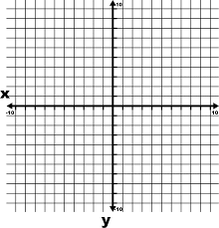
Remember, the (x, y) plot ….
Start from the 0,0 or the middle, move right for positive x values and left for negative x values.
Then go up for positive y values and down for negative y values.
Example of linear functions in two variables are
Y= 4x + 5
Y= -2x – 6,
In standard form the equations are written this way, Y-4x = 5 ( in slope intercept form Y= 4x+5, )
Y-4x=5
+4x +4x
Y=5+4x

How to find the equation from the graph.
x | y
1 | 2
3 | 6
Step 1: Find two points on the line which lie on the intersection of the two lines in the graph. (so we know they exactly have those values and not some decimal)
Step 2: table the two values .
Step 3: we have the formula for the equation as y=mx+b,
m is the rate of change= ( remember bump bump)
6-2= 4
3-1= 2
Now divide $\frac{4}{2}$ = 2
Step 4: b is the value of y when x=0, or the value of y when we begin the problem
(like the beginning of the race , you are at start line or at 0)
Or if we are emptying a can of water, we start with a cup of water, so 1 cup is the value of b.
x | y
0 | 4
1 | 5
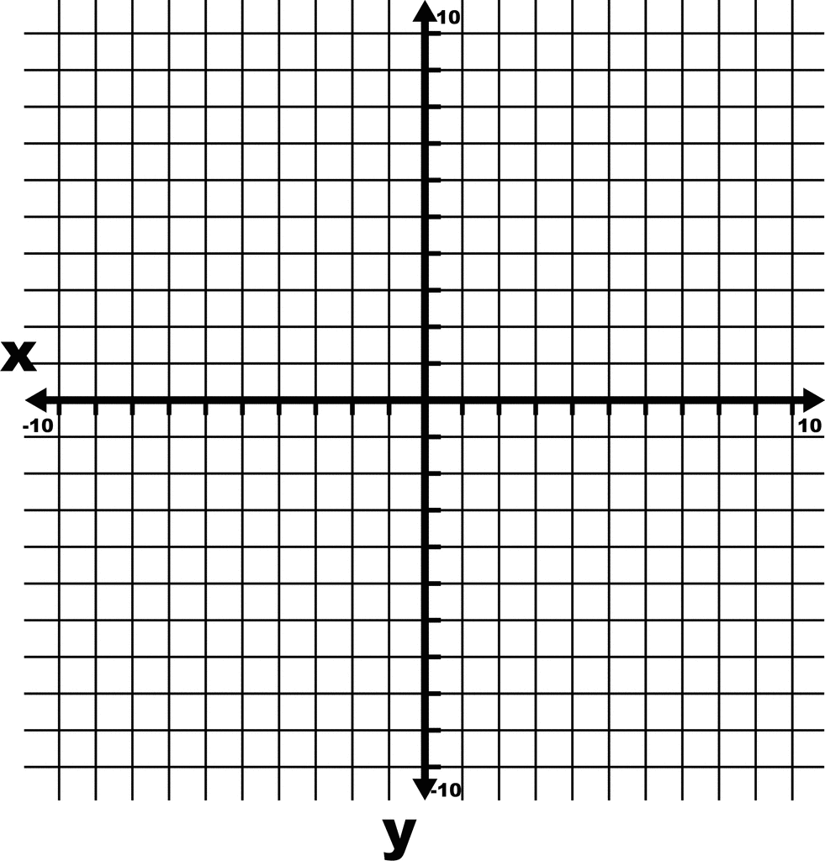
In this case the line meets or intercepts the y axis at y=4,

In a table b can be found when x=0 !!
Now write down how to find the value of b when given only the points….__________________________________________________________________________________________________________________________________________________________________________________________________

